PAPER TEMPLATE

TITLE: BOLD, UPPER CASE, TIMES NEW ROMAN, 14 PT CENTERED

**First A. Author1*, Second B. Author, Jr.1, Third Author2, Fourth C. Author3**

1The University of Tokyo, Hongo 7-3-1, Bunkyo-ku, Tokyo 123-4567, Japan

2University of Maryland, College Park, MD 20742, USA

3Shanghai Jiao Tong University, 800 Dong Chuan Rd. Minhang District, Shanghai 200240, China

Abstract

The guidelines for the preparation of papers to be submitted for the 18th International Heat Transfer Conference, IHTC-18, can be found here. Accepted papers will be published in the International Heat Transfer Conference Digital Library (<https://www.ihtcdigitallibrary.com/>), and a copyright transfer to Begell House Inc. will be required. The present file can be used as a template for Microsoft Word™ and also serves as a formatting guide for users of other text processing software. Papers that do not strictly follow these guidelines will not be accepted. The paper, saved as a PDF file, must be submitted through the Online Submission System of the IHTC-18 Conference (<https://submissions.ihtc18.org/>).

**KEYWORDS:** Times New Roman, 10-point type size, Convection, Computational methods, Heat exchanger, Cooling turbine blade, Film cooling, High temperature

**1. INTRODUCTION**

The paper mustbe formatted in accordance with these guidelines. At least one author needs to be registered by July 03, 2026 for an accepted paper to be included in the proceedings and in the conference program. Each registration can be associated with the publication of one single paper. The review process will be conducted by regional editors, who will be automatically selected based on the geographical location of the institution of the corresponding author.

**2. LENGTH AND LAYOUT**

Papers should be prepared in one-column format, A4 size (210 × 297 mm), borders of 20 mm all around and a minimum of 8 pages. Regular contributed papers are limited to 15 pages, while papers from plenary and keynote lectures are limited to 30 pages. These page limits include tables, figures and references. The maximum allowable size for the PDF file is 4 Megabytes.

The layout of the paper should follow the style of this document, starting with a title, author(s) name(s) and affiliation(s). The title should appear 40 mm below the top edge of the first page. It should be brief, clear, and descriptive, written in Times New Roman, 14-point all bold capital letters (except if formulae or symbols appear in the title), and centered horizontally. Leave one blank line below the title and include authors’ names in 11-point Times New Roman bold characters. Authors’ affiliations should be in Times New Roman regular 11-point characters. One blank line should be included between the authors’ names and their affiliations.

**2.1 Abstract.** A brief abstract (100 - 250 words) should appear beneath the affiliation(s) of the author(s). It should summarize the paper’s most significant contributions. It is also important to indicate briefly the paper goals, methods, results and conclusions. Avoid abbreviations, diagrams, and references in the abstract. The abstract must be complete and understandable without reference to the paper text. Leave a blank line between the Authors’ affiliations and the Abstract, and leave a blank line between the Abstract and Keywords.

**2.2 Keywords.** Up to 6 keywords should be selected to describe the main features of the paper. Keywords should be separated by comma and typed in Times New Roman 10-point size. Leave two blank lines between keywords and the heading of the first paper section.

**2.3 Header and Footer.** Page header of the first page is different from those of the remaining pages. The IHTC logo and the conference title only appear on the first page. The paper number should be included on the header of all pages. The paper number corresponds to the one provided by the Online Submission System during abstract submission. The footer of the first page contains the e-mail address of the corresponding author.

**2.4 Main Text.** The main text of the paper should be single-spaced, in Times New Roman 11-point font, and justified on both sides. Include a blank line between paragraphs.

**3. HEADINGS AND EQUATIONS**

First-level headings need to be centered, in Times New Roman capital letters, with bold characters 12-point type size. These headings should be numbered sequentially. Leave two blank lines before and one blank line after first-level headings.

**3.1 Second-Level Headings.** Second-level headings should be typed in Times New Roman, 12-point bold characters, with only the first letters of each word in upper case. Second-level headings should be typed flushed left, starting with the section number, followed by a period and the corresponding number of the heading within the section. A period and one letter space must immediately follow second-level headings. The paper text should immediately follow these headings, in regular Times New Roman 11-point type size characters, without further indentation. Leave one line space above second-level headings.

*Third-level headings.* Third-level headings should be placed at the beginning of a paragraph in *italic characters*. Capitalize only the first letter and underline the whole heading. A period and two letter spaces should follow third-level headings. The paper text should immediately follow these headings, in regular Times New Roman 11-point type size characters, without further indentation. Leave one line space above third-level headings.

Equations should be centered and with one-line spaces above and below to distinguish them from the text. Use commonly available fonts such as Times New Roman in your equations. Do not insert equations in a non-editable picture format. All equations should be numbered consecutively in order of appearance, as illustrated below by eqs. (1) and (2). In the text, refer to an equation as, for example, eq.(1), with no space between the word “eq.” and the Arabic numeral corresponding to the figure number inside parentheses. However, when starting a sentence, the word “Equation” should not be abbreviated. Equation numbers should be flushed right, preferably on the same line of the equation.

Subscripts and superscripts should be clearly typed. Numbers and letters that are intended to be subscripts or superscripts should not be aligned with the rest of the text. The nomenclature must not be ambiguous.

 (1)

and

 (2)

Do not use punctuation at the end of equations. Align equal signs when equations are stacked with no intervening words. All data should be reported in SI units. Decimal places should be separated by a period, and not by commas or centered dots.

**4. FIGURES AND TABLES**

**4.1 Figures.** Care should be taken to ensure that figures fit within the text length. As a general rule, font size in the figures should be comparable to that of the main text. Color and black/white figures are allowed, with sufficient resolution to permit high quality reproduction. Figures should be centered, with one-line spaces above and below them. Use pdf, jpg, tiff, gif, or similar formats for high quality figures.

Figures should be numbered consecutively in order of appearance. In the text, refer to a figure as, for example, Fig. 1, with a single letter space between the word “Fig.” and the Arabic numeral corresponding to the figure number. However, when starting a sentence, the word “Figure” should not be abbreviated. Place figures as close as possible to their first citation in the text. For the caption, type the word “Fig.” and its number followed by a two-letter space. Then, type the caption in regular Times New Roman 11-point type size characters. Captions should be in single space, with an initial capital letter only for the first word and for proper nouns.

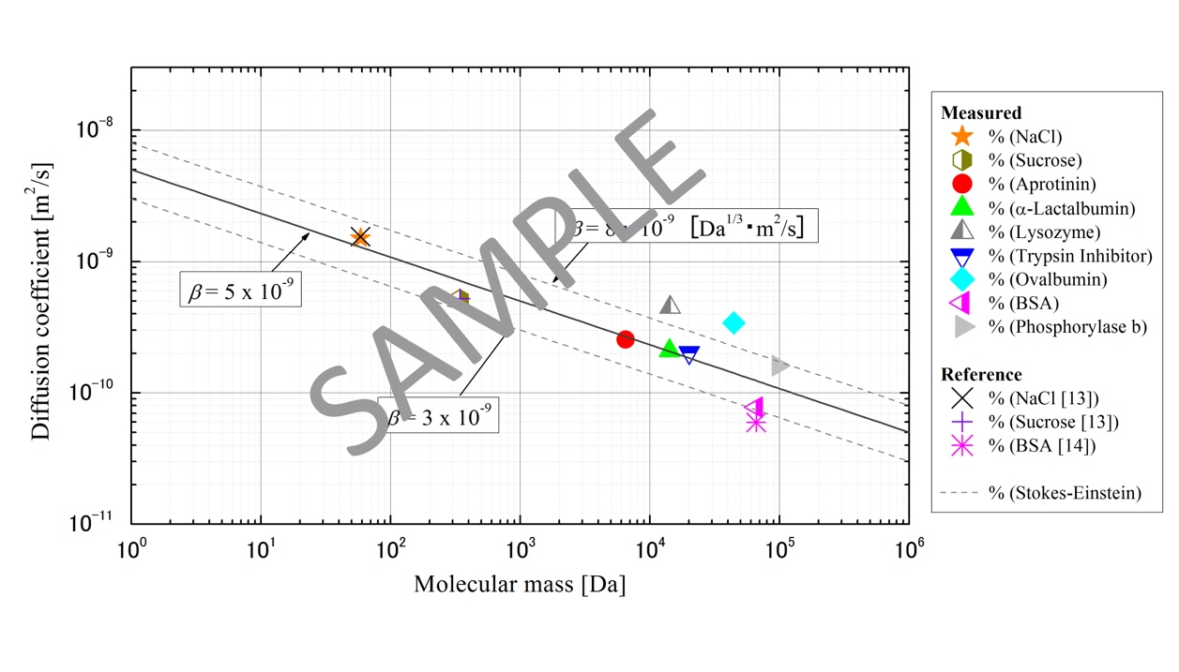

**Fig. 1** One-line captions are centered, with one-line spacing above and below.

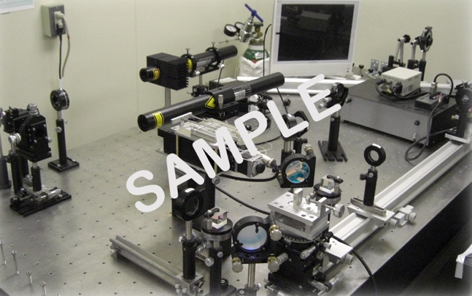

**Fig. 2** Captions with two or more lines should be left-aligned below the figure. Add one-line spaces above and below the figure caption.

**4.2 Tables.** When tables are mentioned in the text, they should be referred to as, for example, Table 1, *i.e*., with a single letter space between the word “Table” and the Arabic numeral. Tables should be numbered consecutively in order of appearance.

Captions should appear above the respective tables. Leave a single blank line above the table caption and a two-line space between the table and the start of the following text. The caption must include the word “Table”, followed by the table number and by the text of the caption, all centered. Use horizontal rules above and below to separate title from column heads, ranks within column heads, column heads from table body, and table body from table footnotes or sources. The tables must be typed in Times New Roman, 11-point size, centered characters.

**Table 1** Table captions go above the table. Captions that are 2 or more lines long should be flushed left. Use one-line spaces above and below the caption.

|  |  |  |  |  |
| --- | --- | --- | --- | --- |
| Case | Diameter, (mm) | (Hz) | We | St |
| 1 | 0.5 | 731 | 117 | 0.15 |
| 2 | 0.5 | 1799 | 620 | 0.16 |
| 3 | 1.3 | 198 | 124 | 0.17 |

**5. NON-ENGLISH-SPEAKING AUTHORS**

Papers must be written in English. Reviewers will not provide corrections for grammar, spelling, or language use. As there is no editing stage for publication-ready manuscripts, it is the authors’ responsibility to ensure that the presentation quality of their papers matches the high standard of their research.

**6. CONCLUSIONS**

**Paper Size:** A4 (210 × 297 mm).

**Margins:** 20 mm margins all round.

**Line Spacing:** Single-spaced with one blank line between paragraphs. No paragraph indentation.

**Justification:** Full (left and right) justification.

**Page Numbering:** Centered, at the bottom of the page.

**Figures and Tables:** Figures and tables must appear close to their first citation in the text and should not be grouped at the end of the paper.

**PDF file:** Submissions will only be accepted as a PDF file, with maximum size of 4 MB.

**Submission Site:** <https://submissions.ihtc18.org/>

**Submission Deadline:** Full draft paper must be submitted by December 5, 2025.

**ACKNOWLEDGMENTS**

Acknowledgements should be placed immediately after CONCLUSIONS, if necessary.

**NOMENCLATURE**

Editors of major heat transfer journals have adopted a common list of symbols, which can be found in the Journal of Heat Transfer, Vol. 121, No. 4, pp. 770-773, November, 1999. Authors should use this list of symbols in their papers submitted for IHTC-18. Symbols which are defined in this list are not required to be included in the paper nomenclature. A brief nomenclature defining uncommon or non-standard symbols should be presented in two columns, immediately above the REFERENCES. SI Unitsmust be used throughout the paper.

Be dimensionless variable ( - )

*Ĉ* second variable (s2)

*QA* third variable (kJ)

*wx* fourth variable (m2/s)

*ϕ*(*Ω*) function

*ζ* dimensionless variable ( - )

*Ω* fifth variable ( s-1 )

**REFERENCES**

Referencesshould be numbered consecutively in accordance with their order of appearance in the text. Citations should be made by using Arabic numerals in square brackets (for example, [4]). Papers with incorrectly formatted or incomplete references will not be accepted. References should be in Times New Roman, 9-point type size, justified, first line flush left and remaining lines indented. The examples below show the format of different reference sources.

[1] Colburn, A. P., “A method of correlating forced convection heat-transfer data and a comparison with fluid friction”, *Int. J. Heat Mass Transf.*, 7(12), pp. 1359-1384, (1964). **Journal Paper**

[2] Nield, D.A. and Bejan, A., *Convection in Porous Media,* New York: Springer-Verlag, pp. 125–176, (2005). **Book**

[3]Buyevich, A. and Alexandrov, D.V., *Heat Transfer in Dispersions*, Connecticut: Begell House, Available at http://www.edata-center.com/ebooks/b7f98f1e271b3e77a.html/ EBooks [accessed May 5, 2005] (2005). **E-Book**

[4] Yang, W. and Kim J.H. Eds., *Rotating Machinery*, New York: Begell House, (1992). **Edited Book**

[5] Nishikawa, K. and Ito, T., “Augmentation of Nucleate Boiling Heat Transfer by Prepared Surfaces,” In T. Mizushina and W.J. Yang, Eds., *Heat Transfer in Energy Problems*, Washington, D.C.: Hemisphere Publishing, pp. 111–1182, (1982). **Chapter in Edited Book**

[6] Ma, T.M., “Effects of Geometrical Shapes of Reentrant Grooves on Boiling Heat Transfer from Porous Surfaces,” Heat Transfer 1986, *Proc. of 8th Int. Heat Trans. Conf.*, vol. 4, pp. 2013–2018, (1987). **Conference Proceedings**

[7] Kasagi, N., Hasegawa, Y., Fukada, K. and Iwamoto, K., “Control of Turbulent Transport: Less Friction and More Heat Transfer,” *Proc. of 13th Int. Heat Trans. Conf.*, IHTC14-23344, pp. 1-16, (2010). **Conference Proceedings**

[8] Richmond, J., *Steady State Thermal Conductivity*, Ph.D. Thesis, University of Connecticut, (2004). **Dissertation**

[9] Author, A.A. and Author, B.B., *Title of document*. Retrieved month day, year, from http://Web address, (Date of publication). **Web Document**

[10] Author, A.A. and Author, B.B. Title of article. In Title of book or larger document (chapter or section number). Retrieved month, day, year, from http://www.someaddress.com/full/url/, (Date of publication). **Chapter or Section of a Web document**

[11] Author, A.A., & Author, B.B., “Title of article,” *Title of Journal, volume number*. Retrieved month day, year, from http://www.someaddress.com/full/url/, (Date of publication). **Online Scholarly Journal Article**